Calculation of the speed of Type II Radio Burst Based on Digital Image Processing and Its Application

A thesis presented by

Wang Jue

to

The School of Intensive Instruction in Sciences and Arts

in partial fulfillment of the requirements

of the course *University Physics*

Nanjing University

December, 2013

**Abstract:**

The speed of type II radio burst concerns many aspects of astronomy research, but its selection and calculation is time-consuming. This thesis aims at picking up valuable information from images and calculating burst's speed automatically with computer, based on digital image processing.

**Keywords:**

type II radio burst, calculation of speed, digital image processing.

**§1.Introduction**

The solar radio burst takes place in the active zone of the surface of the sun. It is a process that changes rapidly and its radiant flux can be thousands of times more compared to the other areas of solar surface. It is discovered in 1942, and it is proved to have significant importance on observing the activities of the sun. Since then many researches on its characters have been done, many of which includes the speed of radio burst, mainly of type II. Those researches require a lot of calculation on the speed but it is time-consuming. With digital image processing, the speed can be calculated automatically with a computer and lots of time and energy can be saved.

The second section gives brief introduction of the calculation of type II radio burst, showing the problems to solve in order to calculate with a computer. The third section shows methods based on digital image processing to deal with the problems occurred in Section Two. The last section gives a final method to automatically calculate the speed, and a few problems remained.

**§2.Speed of Radio Burst**

Through Radio dynamic spectrograph, we can get the change of radio intensity of different frequencies as time differs. As the Figure 1 shows, the x axis represents time, and the y axis represents frequency, and the bright area is the time and frequencies that radio bursts take place. There are two types of burst we can identify. The left one that decreases rapidly is type III, and the one on the right side whose frequency of burst decreases slowly as time changes is the type II radio burst whose speed requires to be calculated. It normally has two branches, fundamental frequency f and harmonic frequency h.

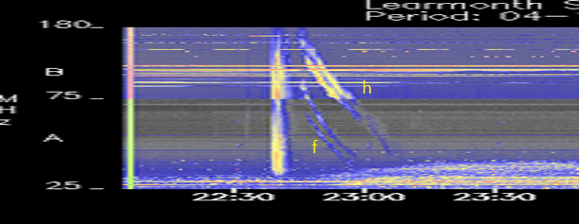

Figure 1. an example of Radio Dynamic Spectrograph

The frequency of f has a connection with the coronal plasma density n as

[1](1)

And the connection between the coronal plasma density Ne and the height of the shock wave created by the burst r is as

[2] (2)

Where, $a_{1}=1.36×{10}^{12}m^{-3}$, $a_{2}=1.68×{10}^{14}m^{-3}$, $c=-2.1$,and $d=-6.13$ are the values which fit to the equatorial background.

With equation (1) and (2), the speed of the shock wave, which is the speed of the type II radio burst can be calculated by finding the speed that the r decreases with time.

Calculating the speed involves lots of calculation, and it is time-consuming. But a computer can find the frequency at each time spot, and do the mathematics with a high speed, saving time and avoiding mistakes. The problem is how to get the frequency at each time. The next section gives a method to solve this goal.

**§3.Digital Image Processing**

In the computer, the figures are stored and displayed as a set of pixels. Each pixel has three values that represent the color of it. As Figure.1 shows, the margins of the burst zone are not clear and for each time spot, there might be a lot of pixel representing different frequencies that can be the exact frequency of the wave at that time. So the figure needs to be processed with Image binarization and erosion.

Image binarization is a method to convert image with different colors into a image with only two colors: black and white. Computer goes through every pixel and adds all its three values together. If the amount if bigger than half of its max value, then determines that this pixel is black, which is the max value, and otherwise white, which has zero value. With this method, the image can be transformed into a set of pixels with binary values: max or zero.

After the binarization, the erosion turns the image into one that can be processed with the algorithm mention last section. Erosion is an algorithm that proceed as follows:

1. Determine a 3 $×$ 3 structure pixel that is a set of 9 pixels with one certain color, which in this case the color of the burst zone(whether black or white after the binarization);
2. Use the center of the structure pixel to compare each of the pixel in that image. For each pixel, compare the pixels covered by the structure pixel pare by pair and if all of the pixels have the same color as the ones that cover them, the pixel to be compared is the structure pixel’s color, otherwise set it to be the opposite.

Figure 2. shows an example of erosion after the binarization. X is the original image, B is the structure pixel with an origin, and X $θ$ B is the image after the process

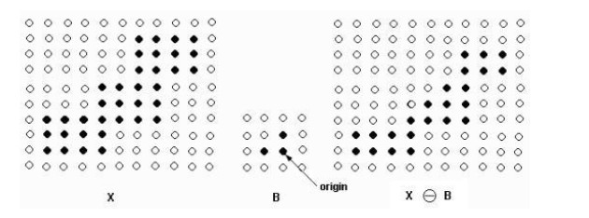

Figure 2. An example of Image erosion

With this method, the image can be processed to shrink the burst zone until it can give each time spot a less than a certain number of frequencies. By picking middle frequency of each time spot, the qualified image of a function if formed.

**§4.Final methods of Calculation**

With the ideas and methods mentioned above, a complete algorithm for calculating the speed of the shock wave created by type II radio burst can be given:

1. Use Image brinarization to convert an Radio Dynamic Spectrograph into an image with binary color;
2. Use Image erosion to decrease noise of the image obtained by 1) until each time spot has less than a certain number of valid pixels representing frequencies;
3. For each time spot pick the middle frequency among those obtained by 2) and for each frequency, solves the equation (1) and (2) to obtain a r.
4. Use the data obtained by 3) to form a function from time T to height r, and with this function, the speed at each time spot can be obtained by calculating the derivate of the function at that time spot.

This Algorithm can obtain speed required automatically at every time spot. Yet the problem of precision exists. During the binarization and erosion, some useful and valid point might be lost and picking middle frequency can cause errors. Generally, this method will work as expected and return numbers generally accurate than numbers calculated manually.

**Reference:**

[1] [Saito, K.](http://adsabs.harvard.edu/cgi-bin/author_form?author=Saito,+K&fullauthor=Saito,%20K.&charset=UTF-8&db_key=AST), [Poland, A. I.](http://adsabs.harvard.edu/cgi-bin/author_form?author=Poland,+A&fullauthor=Poland,%20A.%20I.&charset=UTF-8&db_key=AST) & [Munro, R. H.](http://adsabs.harvard.edu/cgi-bin/author_form?author=Munro,+R&fullauthor=Munro,%20R.%20H.&charset=UTF-8&db_key=AST). *A study of the background corona near solar minimum* [J], Solar Physics, vol. 55, Nov. 1977, p. 121-134..

[2] [Newkirk, Gordon, Jr.](http://adsabs.harvard.edu/cgi-bin/author_form?author=Newkirk,+G&fullauthor=Newkirk,%20Gordon,%20Jr.&charset=UTF-8&db_key=AST) *Structure of the Solar Corona*[J], Annual Review of Astronomy and Astrophysics, vol. 5, p.213.